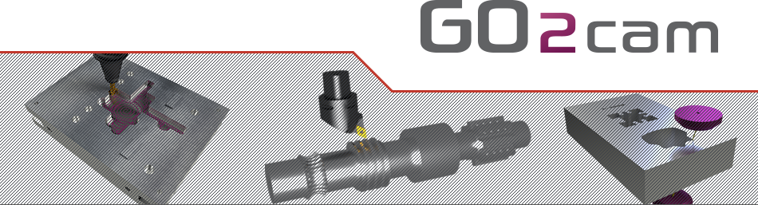

Tornos GT13



The contents of this manual are relative to GO2cam version:

**V6.08**

**March 2021**

**About GO2cam**

All information contained in this document can be modified without prior notice. Unless specified, the companies, the names and data used in the examples are unreal. Any part of this manual cannot be reproduced or transmitted for any purpose or by any means without a written permission of GO2cam International.

Copyright © 2009-2021 GO2cam International. All rights reserved.

Portions of this software are protected by copyright and are own by © 2018 Siemens Product Lifecycle Management Software Inc.

Portions of this software are protected by copyright and are own by © 2020 Datakit.

Portions of this software are protected by copyright and are own by © 2019 MachineWorks Ltd.

Portions of this software are protected by copyright and are own by © 2020 Open Design Alliance.

Portions of this software are protected by copyright and are own by © ModuleWorks GmbH.

**Warning to the user:** all the forms included in this document are given as examples only.   
GO2cam International cannot be responsible for any consequences of their use.

Summary

1 Machine description 3

2 Output Explanation 4

2.1 G800 4

2.2 G801 5

# Machine description

The package has been validated only for the configuration bellow with the part installed with package.

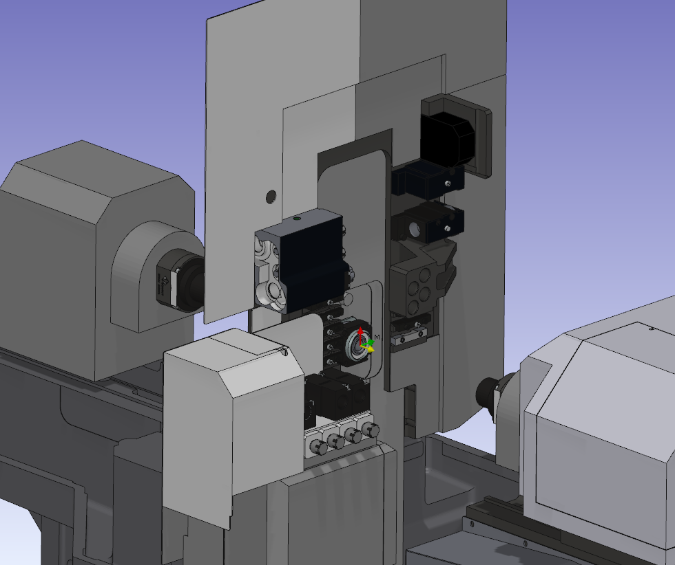

# Output Explanation

## G800

G800 A B C D E F

|  |  |  |
| --- | --- | --- |
| **Parameter** | **Description** | **Picture** |
| A | Stock diameter |  |
| B | Part length |  |
| C | Part length in rework |  |
| D | Feeding allowance |  |
| E | Frontwork facing allowance |  |
| F | Rework facing allowance |  |

## G801

G801 A B C D E F I

|  |  |  |
| --- | --- | --- |
| **Parameter** | **Description** | **Picture** |
| A | Cut off parting tool number |  |
| B | Cut off tool width |  |
| C | Cut off tool angle |  |
| D | Spindle mode |  |
| E | Spindle speed according with D parameter |
| F | Initial feedrate |  |
| I | Maximum spindle speed |  |